# Chapter 3

## Monthly temperature data in New Jersey

Download the monthly temperature data for your favorite state from the website <https://www.ncei.noaa.gov/access/monitoring/climate-at-a-glance/statewide/time-series>

Compute the STL decomposition, printing out the time series, trend, seasonal components, and remainder versus time. Print out the plots and describe the data.

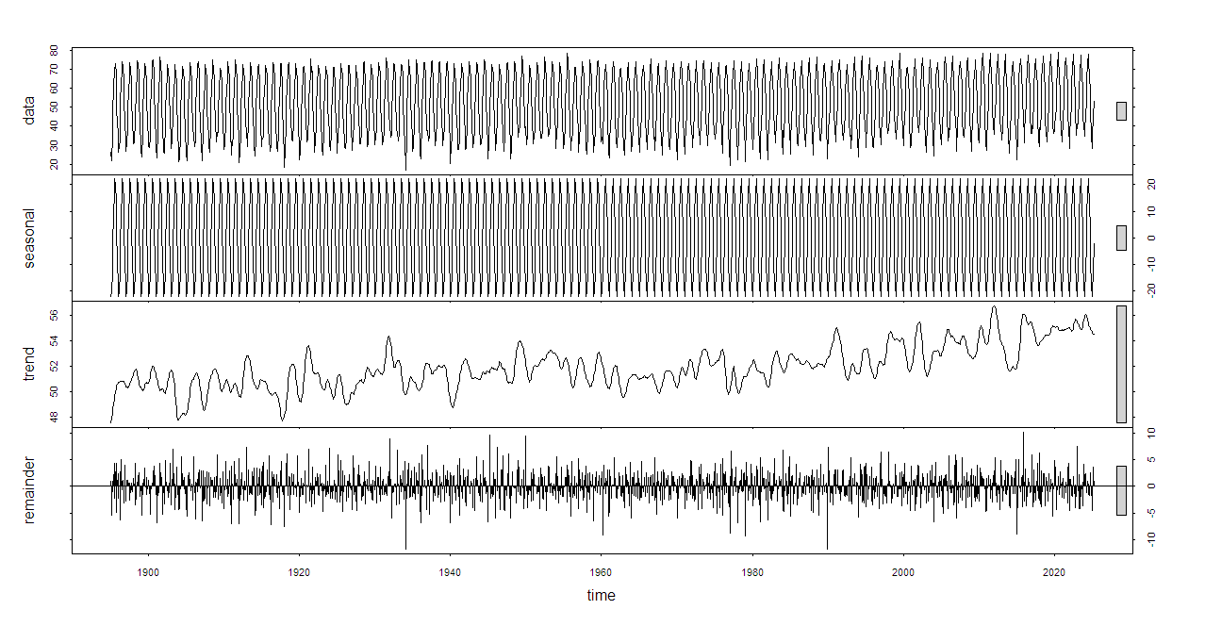

Figure 1: STL Decomposition of Monthly Temperature (NJ)

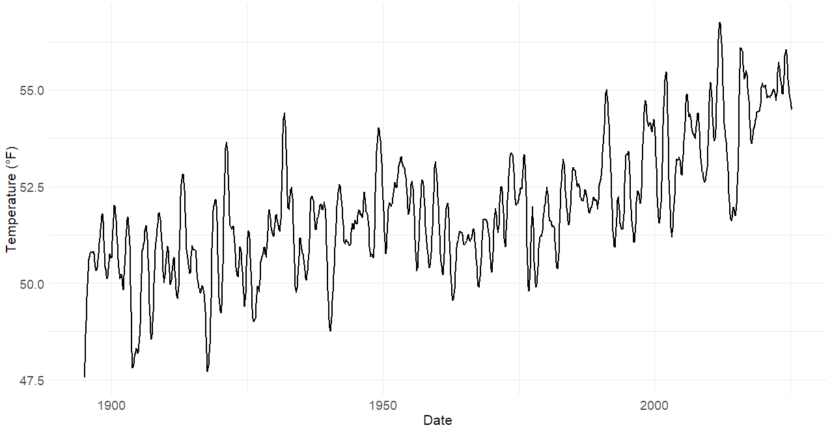

Figure 2: Trend Component of NJ Monthly Temperature

### Describe the data

This STL decomposition plot shows the original time series broken into seasonal, trend, and remainder components. The seasonal component displays a strong, regular repeating pattern that remains consistent over time, suggesting stable yearly seasonal data. The trend component shows a fluctuating trend that is not stable, with gradual increases before 1960 and a faster upward movement afterward, though still with ups and downs over the years. The residual component is centered around zero, capturing irregular variations not explained by the trend or seasonality. While mostly stable, the residuals show some distinct peaks approximately every 20 years, suggesting occasional unusual events or outliers. Overall, the STL decomposition effectively separates meaningful structure from random variation.

## Stock prices

Download a timeseries of stock prices from Bulk Stock Data Downloader.

<https://bulkstockdatadownloader.app/>

You may pick any stock you might find interesting or pick one of these: NVAX, ZIM, or MULN. Complete an STL analysis and describe the trend, seasonal component, and residual. You may use any application you want, but a sample R code is shown below.

# Load necessary libraries

library(readr)

library(dplyr)

library(lubridate)

library(tsibble)

library(fabletools)

library(feasts)

library(ggplot2)

# Read the CSV file

file_path <- "C:/Users/joean/Desktop/A_DSSA_Time_Series/PLTR_stock.csv"

stock_data <- read_csv(file_path)

# Rename columns

colnames(stock_data) <- c("Date", "Close")

# Convert to tsibble and parse date

stock_data <- stock_data %>%

mutate(Date = mdy(Date)) %>%

arrange(Date) %>%

as_tsibble(index = Date)

# Aggregate to monthly frequency

monthly_stock <- stock_data %>%

index_by(Month = yearmonth(Date)) %>%

summarise(Close = mean(Close, na.rm = TRUE))

# Perform STL decomposition using fpp3's STL()

stl_result <- monthly_stock %>%

model(stl = STL(Close))

# Extract components and plot

components <- components(stl_result)

# Plot the STL decomposition

autoplot(components)

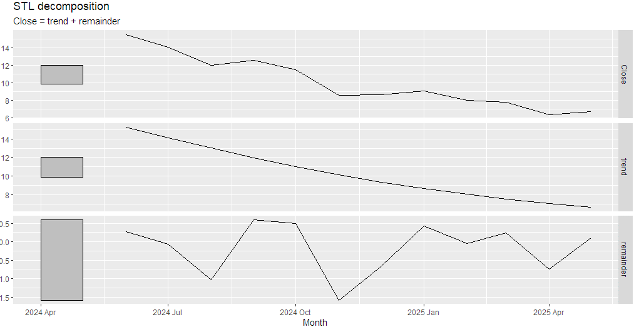

### Describe the data

This STL decomposition plot breaks down the monthly NVAX stock prices into trend and residual components, with no seasonal component extracted. The trend line clearly shows a downward direction, indicating a gradual but consistent decline in stock price from April 2024 to April 2025. The decomposition output does not include a seasonal component, likely because the dataset covers only about 12–13 months. The remainder component captures short-term, irregular fluctuations around the trend. Overall, the plot suggests a stock in gradual decline irregular residuals.